Patricia Piccinini's transgenic creatures pay a visit to the Patricia Hotel
Transgenic human-animal sculptures by Australian artist Patricia Piccinini are on display at the Patricia Hotel for the Vancouver Biennale.
Kevin Griffin Updated: September 12, 2018

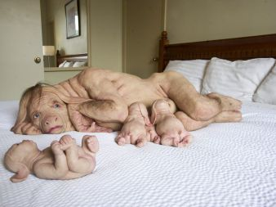

Transgenic human-animal sculptures by Australian artist Patricia Piccinini are on display at the Patricia Hotel for the Vancouver Biennale.

Curious Imaginings
Where:Patricia Hotel
When:Sept. 14 to Dec. 15.
Tickets and info:From $11, imcurious.ca
Looking into Room 107 from the hallway of the Patricia Hotel, all you can see is the back of something not quite human lying on its side a white bedspread.
Once inside the room, you can see it’s a mother and her offspring. Despite the otherwise domestic scene, the effect is to create an altogether unsettling feeling, not only because you’re looking at several transgenic human-animal creatures the likes of which have never been seen in Vancouver before.
It’s also because of where they are.

The Vancouver Biennale has mounted an exhibition of the works of Australian artist Patricia Piccinini in a hotel in the Downtown Eastside rather than in a traditional art gallery.
The mother and her children are called The Young Family. They’re one of several similar works by Piccinini displayed in 17 rooms on the hotel’s second floor.
This pig-human mother has fleshy, pink skin and patches of hair, including a long strip down her spine to a truncated tail at her coccyx. Because pigs have an anatomy similar to humans, they’re considered the best species for xenotransplantation.
Instead of hoofs as you might expect on a pig, she has hands with perfectly shaped fingernails. They’re also clean and clipped which suggests a human level of personal hygiene. She has very blue eyes and long ears that droop over her head.
Also on the bedspread are several of her babies: some are vying for her teats. One girl is on its back playfully grabbing her right foot. Her left foot looks like a hand with an opposable thumb.
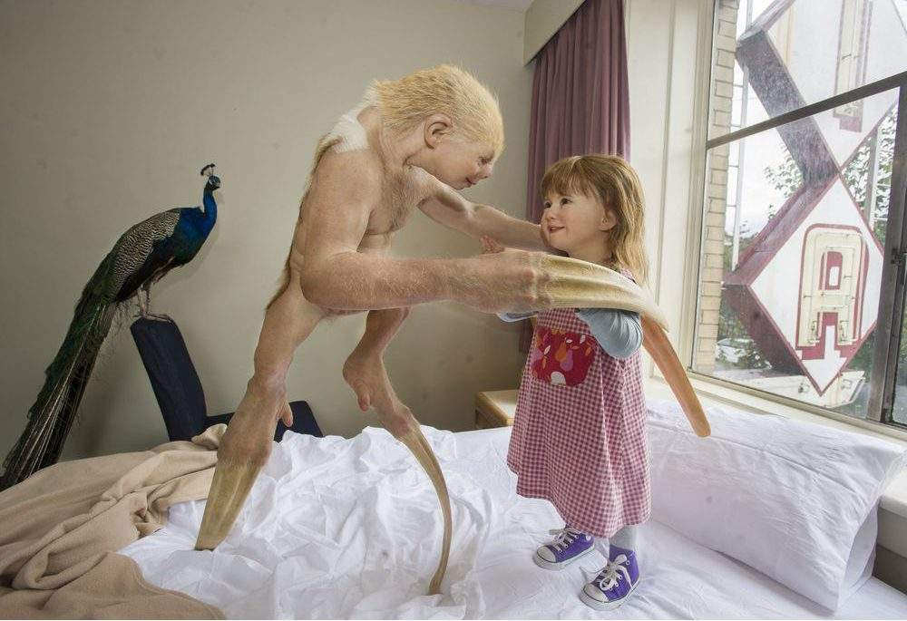
The work creates a relationship between a mother and her children that shows maternal nurturing, something that’s rare to see as a subject matter in a contemporary art setting.
There’s also another relationship: the one between her and us, the viewers. She encourages us to experience empathy.
What did that for me was the way her human-like hands frame her piglike face.
It gave me the impression she knows she and her offspring have been genetically modified to produce something for a human such as a hand or heart or other organ. She looks both aware but resigned to her fate.

The Young Family became a sensation when it shown at the 2003 Venice Biennale, considered the world’s top venue for contemporary art. Piccinini’s exhibition of works that included sculptures of transgenic creatures was such a hit that it immediately launched her onto the world stage as an artist.
Piccinini’s work has been brought to Vancouver through the connections of Marcello Dantas, one of the Vancouver Biennale’s Open Air Museum senior curators.

Dantas was the curator for Piccinini’s hugely popular series of shows in Brazil in 2016 that attracted 1.4 million visitors at three venues. Taken together, they were the most successful exhibitions of contemporary art in the world two years ago.

Dantas thought that the Vancouver Biennale needed more immersive experiences, and imagined showing Piccinini’s work in an unconventional space. While driving by one day, he saw the sign for a hotel named Patricia.
“I immediately thought that a 100-year-old hotel with the creatures inhabiting the rooms would be a fantastic experience,” he said by email.
“I explained it to Patricia (Piccinini) and she immediately grasped and loved the idea.”
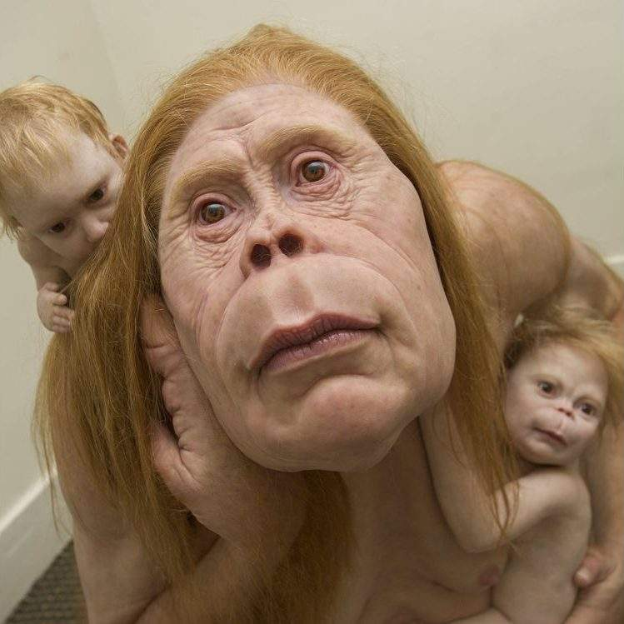
Dantas liked the idea of using a hotel as a setting for art not only because he lives much of his life in them as an international curator who travels around the world, but also because it fitted with Piccinini’s transgenic creatures, which he thinks of as both homeless and inhabiting a world of their own.
“If they are to travel the world, they would need to stay in hotels,” he said.
Piccinini has created one work specially for Curious Imaginings. The Builder in Room 118 is a beaver-human mix perched on a mound of rumpled sheets that resemble a beaver dam. He has bucked teeth, a big tail between his legs and webbed feet. He looks like he’s wondering what’s going to happen next.
As a teenager growing up in Australia, one of the most traumatic events in Piccinini’s life occurred when she was 13 and her mother was diagnosed with cancer. During a period of 10 years, she had a series of operations and bouts of chemotherapy until the cancer finally killed her.
The experience of living with a mother fighting for her own life turned Piccinini inward. She became obsessed with cancer research and the insides of the body.
She taught herself to draw by going to museums of anatomy and pathology to see bodily organs, according to a documentary on the artist called A Dark Fairytale by the Australian Broadcasting Corporation.

Some of her early drawings depict organs in mandala-like shapes; others as organs inside of ornamental vases. At about the time she was learning to draw organs, scientists were in the race to map the human genome. (It was finished in 2003.) She thought creating new life forms was one reason motivating the race.

“I thought: ‘Well, I’ll create one,’” Piccinini says in a 2015 ABC documentary.
In 1994-95, as part of her series of works called Mutant Genome Project, she created LUMP or Life Form With Unevolved Mutant Properties, a 3-D modelled designer baby. It was the start of Piccinini’s science fiction menagerie created with imagination and materials such as silicone, fibreglass, leather and human hair.

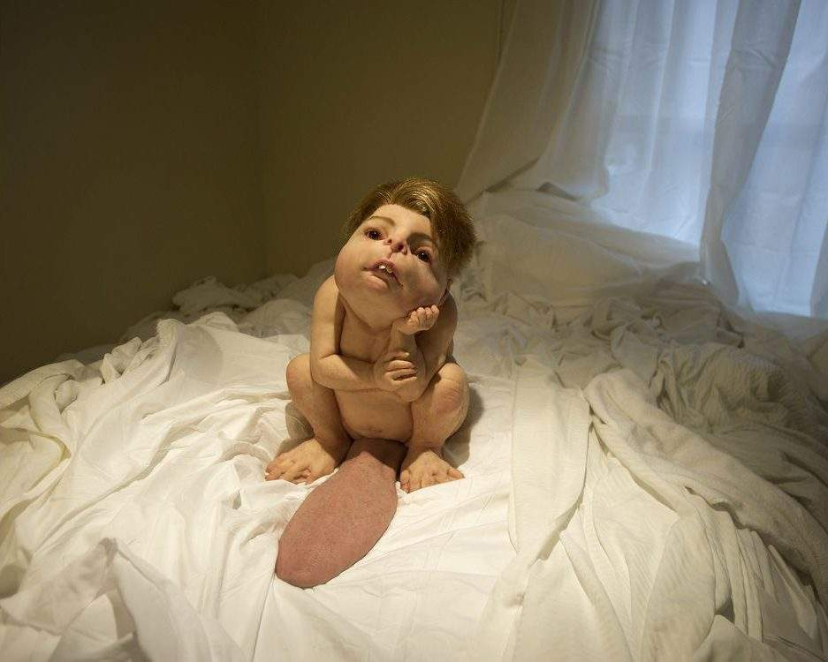

kevingriffin@postmedia.com

